Analytical Report: Programming Contest Platform

1. Project Overview
The objective is to build a programming contest platform using Laravel (backend), Vue.js (frontend), and MySQL (database).
The platform will serve three types of users: Participants, Judges, and Organisers.
- Participants: Compete in contests and practice problems.
- Judges: Create problems, provide solutions, and evaluate submissions.
- Organisers: Manage contests, assist judges, manage participants, and ensure smooth operations.

2. Stakeholder Analysis

Stakeholder | Role / Interest
Participants | Need a platform to practice problems, participate in contests, submit solutions, and view results.
Judges | Need to create problems, provide solutions, evaluate submissions, and manage contest content.
Organisers | Oversee contests, assign judges, manage participants, and monitor smooth functioning.
System Admin | Ensure system reliability, maintain database integrity, and manage security.

3. Functional Requirements

For Participants
- Register/Login to the platform.
- Browse upcoming/ongoing contests.
- Join contests and submit solutions.
- Practice problems in different difficulty levels.
- View submission results and rankings.

For Judges
- Register/Login.
- Create/edit contest problems with inputs/outputs.
- Submit model solutions.
- Evaluate participant submissions (auto or manual).
- View the contest leaderboard and results.

For Organisers
- Register/Login.
- Create/edit contests.
- Assign judges to contests.
- Manage participants (approve, suspend, delete accounts).
- Monitor progress of contests and practice sessions.

Common Features
- Role-based access control (RBAC).
- Notifications for contests, results, and updates.
- Leaderboards for contests.
- Submission history tracking.

4. Non-Functional Requirements
- Performance: Fast loading, minimal latency in submissions and evaluation.
- Scalability: Ability to handle multiple contests and hundreds of participants simultaneously.
- Security:
  - Password hashing and secure authentication (JWT or Laravel Passport).
  - Prevent SQL injection and XSS attacks.
  - Role-based access control.
- Usability: Clean, intuitive UI/UX with Vue.js.
- Maintainability: Modular code with clear separation of frontend and backend.
- Reliability: Ensure the evaluation system and leaderboard are accurate and consistent.

5. System Components
- Frontend (Vue.js):
  - Dashboard (role-specific)
  - Contests listing & details
  - Problem practice interface
  - Submission editor
  - Leaderboard & results page
- Backend (Laravel + MySQL):
  - Authentication & RBAC
  - Contest & problem management
  - Submission evaluation engine
  - Leaderboard & result calculation
  - User management
- Database (MySQL):
  - Users, Contests, Problems, Submissions, ContestParticipants, Leaderboards
- Optional Components:
  - Notification service (email, in-app)
  - Admin panel for overall monitoring

6. Constraints
- The platform must support multiple programming languages (C, C++, Java, Python, and PHP).
- Judges must be able to evaluate both auto and manual submissions.
- Contests and practice problems should support different difficulty levels.
- Organisers should have full control over contests and users without interfering with judge autonomy.

7. Potential Challenges
- Automated Evaluation: Running untrusted participant code safely.
- Scalability: Managing many concurrent submissions in contests.
- Leaderboard Accuracy: Ensuring real-time score calculation without delays.
- Role Management: Properly restricting actions based on user type.
- UI/UX Design: Clean interface for three different user types.

8. ER Diagram
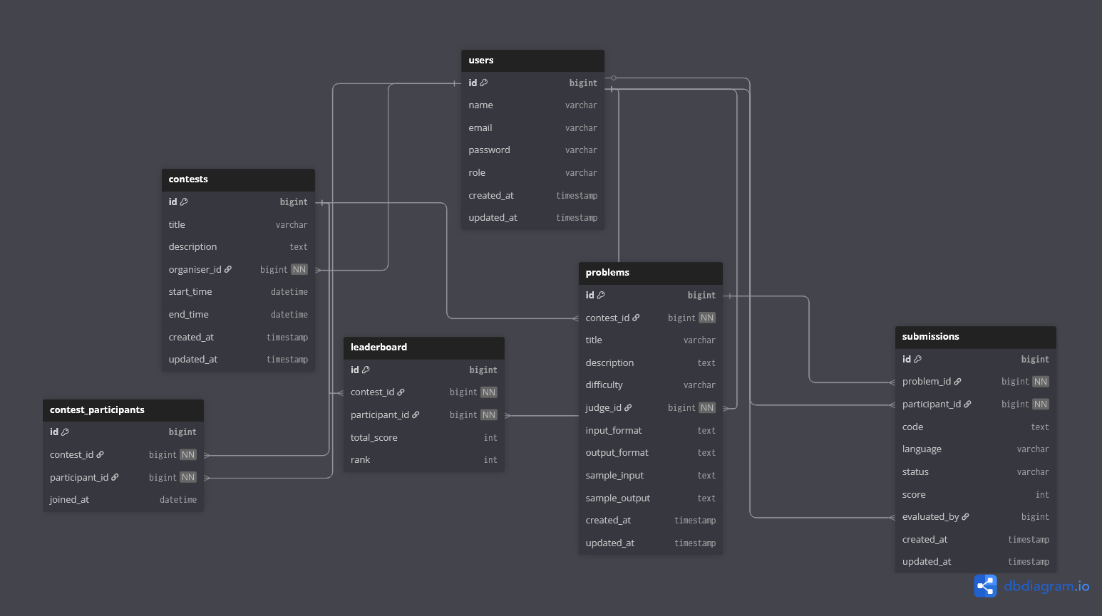
9. Next Steps
- Finalise database schema and API design.
- Define role-based access policies.
- Start frontend layout design for all user types.
- Implement authentication and basic CRUD operations.
- Integrate the submission evaluation engine.
- Add leaderboard, notifications, and practice module.

